1 Which one of the following quantities is a vector?
A Energy
B Temperature
C Momentum
D Pressure

2 The unit of work, the Joule, may be defined as the work done when the point of application of a force of 1 newton is moved a distance of 1 metre in the direction of the force.

Express the joule in terms of the base units of mass, length and time, the kg, m and s.
A kg m⁻¹ s² B kg m² s⁻² C kg m² s⁻¹ D kg s⁻²

3 For which quantity is the magnitude a reasonable estimate?
A frequency of a radio wave 700 pHz
B the Young Modules of steel 700 kPa
C mass of an electron 700 μg
D wavelength of red light 700 nm

4 The magnitude and direction of two vectors X and Y are represented by the vector
diagram below.

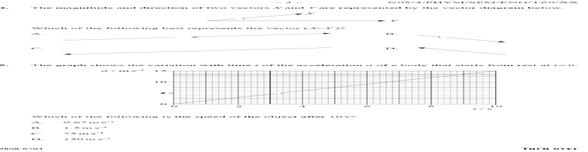

Which of the following best represents the vector (X - Y)?

5 A car driver sharply presses down the acceleration when the traffic light goes green.
The resultant horizontal force acting on the car varies with time as shown.

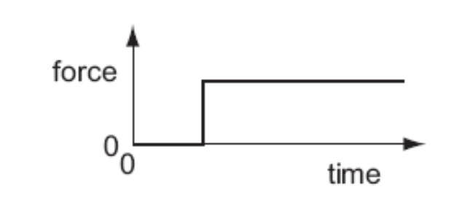

Which graph shows the variation with time of the speed of the car?

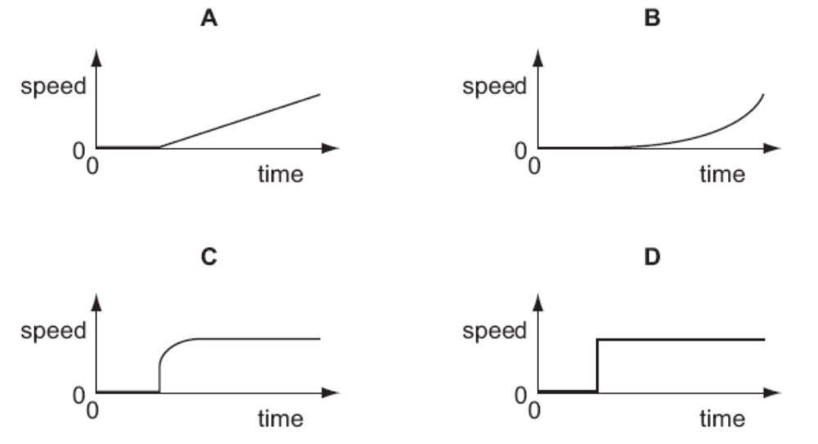

6 The graph represents how displacement varies with time for a vehicle moving along a straight line.

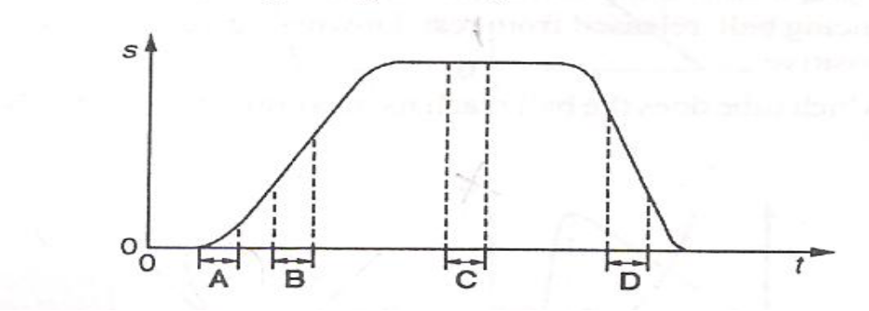
During which time interval does the acceleration of the vehicle have its greatest
numerical value?

7 A boy throws a ball vertically upwards. It rises to a maximum height, where it is
momentarily at rest, and falls back to his hands.
Which of the following gives the acceleration of the ball at various stages in its
motion?
Take vertically upwards as positive. Neglect air resistance.
 | Rising | At maximum height | Falling
A | +9.81ms⁻² | +9.81ms⁻² | +9.81ms⁻²
B | -9.81ms⁻² | -9.81ms⁻² | -9.81ms⁻²
C | -9.81ms⁻² | 0 | +9.81ms⁻²
D | +9.81ms⁻² | 0 | -9.81ms⁻²

8 The diagram shows two balls P and Q at the same height above the ground.

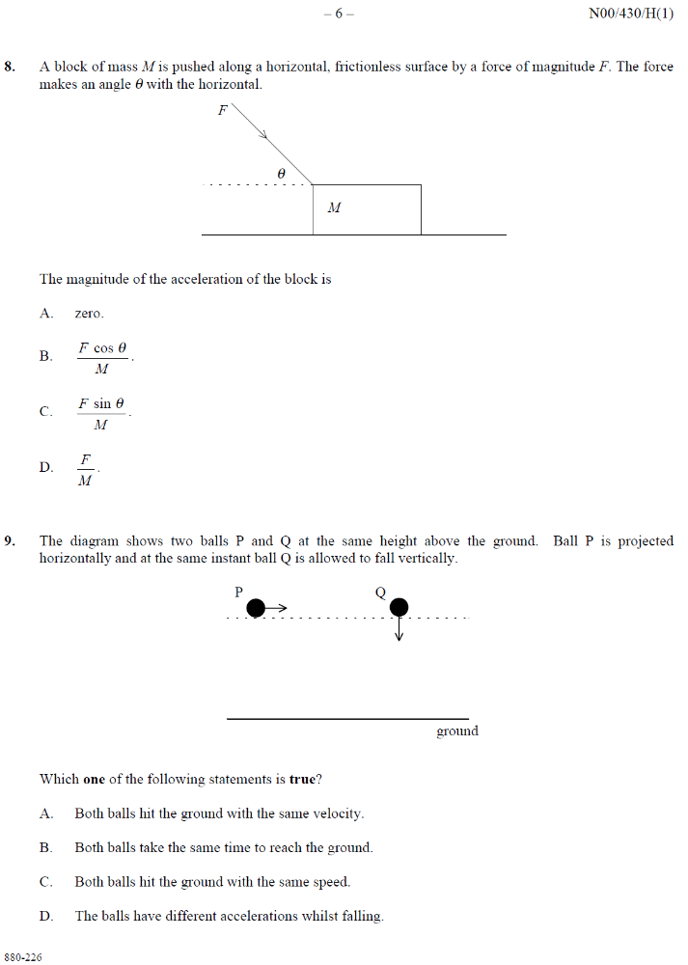

Ball P is projected horizontally and at the same instant ball Q is allowed to fall
vertically.
Which one of the following statements is true?
A Both balls hit the ground with same velocity.
B Both balls take the same time to reach the ground.
C Both balls hit the ground with the same speed.
D The balls have different accelerations whilst falling.

9 In the situation below, a 30 N weight is attached to a block. The block accelerates along a horizontal surface. Friction is negligible.

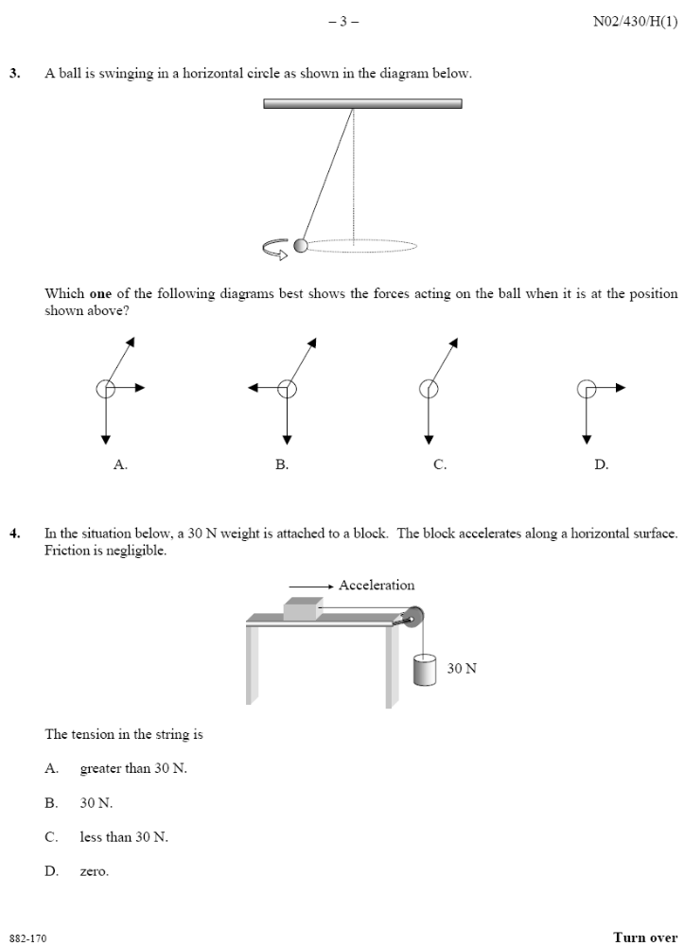
The tension in the string is
A greater than 30 N
B 30 N
C Less than 30 N
D Zero.

10 A ball of weight W slides along a smooth horizontal surface until it falls off the edge at time T.

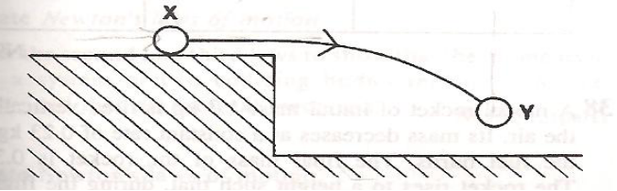

Which graph represents how the resultant vertical force F, acting on the ball, varies
with time t as the ball moves from position X to position Y?

A C
F
T
-W
t
F
T
-W
t

B D
F
T
W
t
F
T
W
t

11 A ball of mass M hits a wall at speed V normal to the wall.
It rebounds with speed v normal to the wall as shown below.
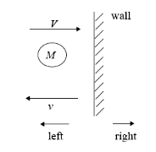

What is the magnitude of the change of the momentum of the ball and the direction of the force that the wall exerts on the ball?

 | Change of the momentum | Direction of Force
A | M (V - v) | To the right
B | M (V - v) | To the left
C | M (V + v) | To the right
D | M (V + v) | To the left

12 Two spheres P and Q approach each other along the same straight line with speeds u_{P} and u_{Q}. After the collision they move apart with speed v_{P} and v_{Q} respectively.

Before:
P
Q

u_{P} u_{Q}

After:
P
Q

v_{P} v_{Q}

Which of the following equations is correct?
A u_{P} + u_{Q} = v_{P} + v_{Q}
B u_{P} + u_{Q} = v_{P} – v_{Q}
C u_{P} – u_{Q} = v_{P} + v_{Q}
D u_{P} – u_{Q} = v_{P} - v_{Q}

13 A long uniform beam is pivoted at one end.
A force of 600 N is applied to hold the beam horizontally.

2.5 m
0.50 m
600 N

What is the weight of the beam?
A 600 N B 800 N C 1000 N D 1200 N

14 A ladder PQ, rests in equilibrium against the rough wall, is shown.
The weight of the ladder is W and the forces acting on the ladder are X and Y.
Which one of the following diagrams correctly shows the directions of these forces?

A B
Y
X
W
P
Q
Y
X
W
P
Q

C D

Y
X
W
P
Q
Q

X

W
Y

P

15 A steel ball is falling at constant speed in air.
Which graph shows the variation with time of the gravitational potential energy E_{P}
and the kinetic energy E_{K} of the ball?

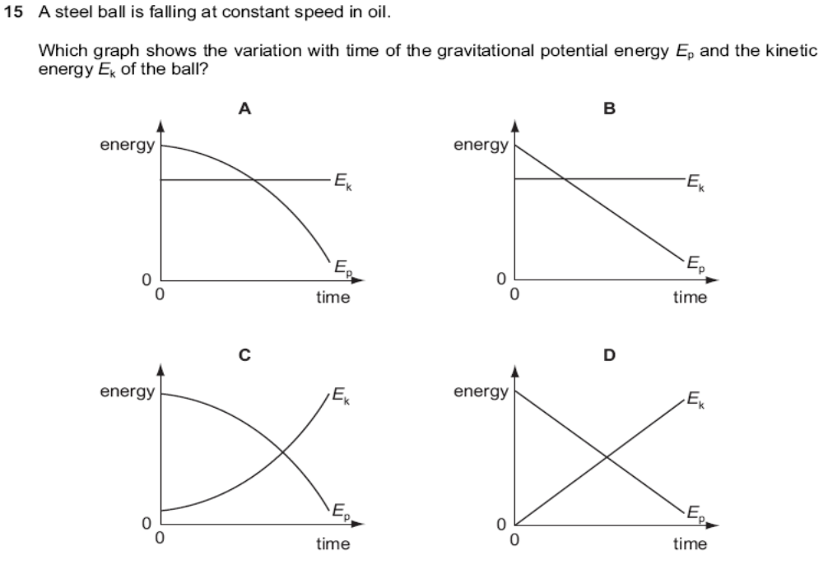

16 Which statement concerning the evaporation and boiling of a liquid is true?
A Boiling always occurs at a higher temperature than evaporation.
B Evaporation and boiling are unaffected by changes in the surface area of the
liquid.
C Evaporation occurs at any temperature whereas the boiling point depends on the
external pressure.
D Evaporation results in the loss of the most energetic molecules from a liquid
whereas in boiling, all molecules have the same energy.

17 Gases have densities of about one thousandth of those of solids.
If the distance between neighbouring molecules of a solid is d, the approximate average distance between neighbouring molecules of a gas is

A 10⁶ d B 10³ d C 10² d D 10 d

18 Figure below shows a U-tube contains water and oil which do not mix.

24 cm
20 cm
oil
water

If the density of the water is 1.0 x 10³ kg m⁻³, what is the density of oil in kg m⁻³?
A 0.83 x 10³ B 0.95 x 10³ C 1.0 x 10³ D 1.2 x 10³

19 The graph below shows how force F varies with extension e for samples of four
materials. The breaking point of the sample is indicated by X.
Which graph represents the behaviour of a typical ductile material?
e
F
A
0
0
X
e
F
B
0
0
X

e
F
C
0
0
X
e
F
D
0
0
X

20 A steel wire of diameter d has a strain 8.0 x 10^{–4} when it is used to suspend a
certain load. If another steel wire of the same length but with diameter ½ d is used
to suspend the same load, what is its strain?
A 3.2 x 10 ^{–3} B 1.6 x 10⁻³ C 8.0 x 10⁻⁴ D 4.0 x 10⁻⁴

21 Young modulus is a measure of the material of its

A strength B stiffness C elasticity D ductility

22 The diagram below shows ripples on the surface of water at one instant of time.
The ripples are moving from right to left and a small object P, is floating in the water. After a quarter of a time period, which letter correctly shows the position of the floating object?

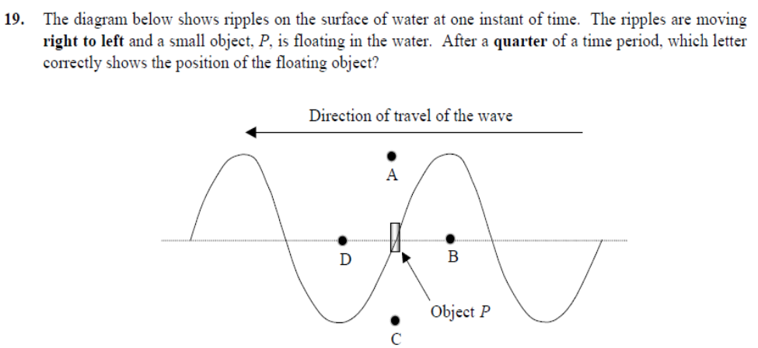

23 The table shows the wavelengths of electromagnetic waves in various parts of the spectrum. For which line in the table is X in the ultra-violet region and Y in the microwave region of the spectrum?

 | X | Y
A | 1 x 10⁻⁷ m | 1 x 10⁻² m
B | 1 x 10⁻⁷ m | 1 x 10⁻⁶ m
C | 1 x 10⁻¹⁰ m | 1 x 10⁻² m
D | 1 x 10⁻¹⁰ m | 1 x 10⁻⁶ m

24 In the diagram below, monochromatic light from a single narrow slit falls on two
narrow slits S₁ and S₂. A system of interference fringes is observed on the screen.

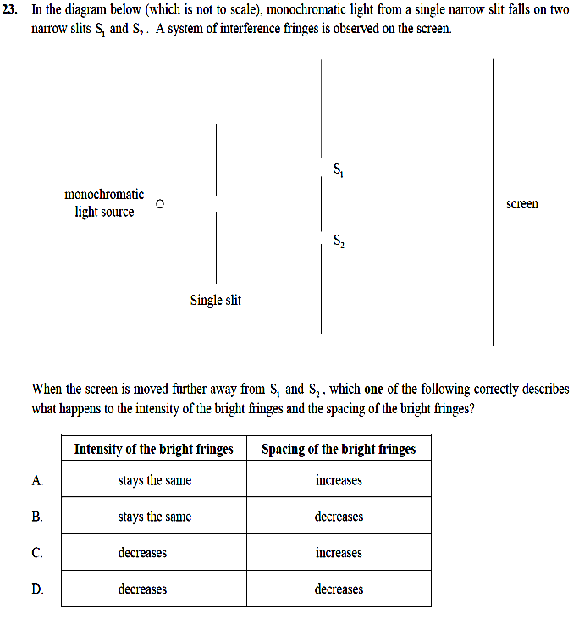
When the screen is moved further away from S₁ and S₂, which one of the following
correctly describes what happens to the intensity of the bright fringes and the spacing of the bright fringes?

 | Intensity of the bright fringes | Spacing of the bright fringes
A | Remains the same | Increases
B | Stays the same | Decreases
C | Deceases | Increases
D | Decreases | Decreases

25 A parallel light beam of wavelength 540 nm is incident normally onto a diffraction
grating which has 5000 lines per cm.
What is the maximum number of orders of maxima which can be formed on both
sides of the central maximum?
A 2 B 3 C 4 D 5

26 The diagram below represents the standing wave of sound inside a pipe.
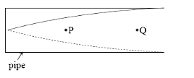

Which of the following correctly represents the displacement of the air at P and Q?

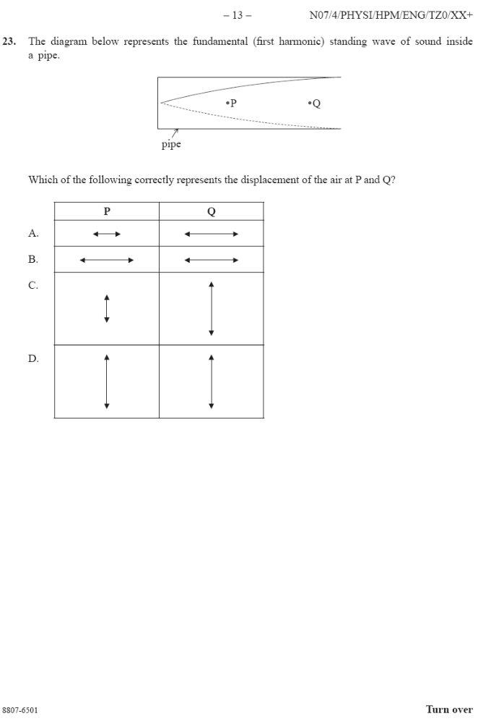

27 Electric field strength is defined as
A product of force and displacement
B force per unit displacement
C product of force and charge
D force per unit positive charge

28 Which diagram shows the electric field between a positively charged metal sphere and an
earthed metal plate?
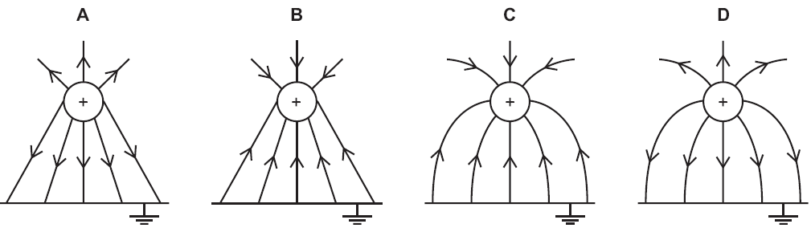

29 Two horizontal metal plates are supplied with a p.d. of 100 V as shown below.
+100 V
0 V
2.0 cm
_
electron

The separation of the plates is 2.0 cm. An electron is released at the lower plate.

What is the acceleration of the electron?
A 5.8 x 10¹⁴ m s⁻²
B 6.8 x 10¹⁴ m s⁻²
C 7.8 x 10¹⁴ m s⁻²
D 8.8 x 10¹⁴ m s⁻²

30 Three lamps labelled “12 V, 24 W” are connected to a power supply as shown.

The current, in ampere, drawn from the supply is
A 0.1 B 0.3 C 2.0 D 6.0

31 An electrical power station supplies a power of 100 MW at a potential difference of
400 kV. If the transmission cable has a total resistance of 10 Ω, the rate of heat loss
along the cable is
A 100 x 10³ J s⁻¹
B 250 x 10³ J s⁻¹
C 625 x 10³ J s⁻¹
D 300 x 10³ J s⁻¹

32 A student wishes to make a heating element of resistance 5.0 kΩ using nichrome
wire. If the wire has a diameter of 0.10 mm, approximately how long should this wire be? (Given: Resistivity of nichrome = 1.0 x 10⁻⁶ Ωm)
A 3.9 cm B 39 m C 6.3 m D 160 m

33 A battery of e.m.f. 1.5 V and internal resistance of 0.50 Ω is used to operate a lamp of resistance 1.0 Ω. What is the power delivered to the lamp?

A 0.50 W B 1.0 W C 1.5 W D 2.0 W

34 Kirchhoff’s first and second laws are statements of the following conservation
principles:
First law second law
A charge energy
B energy current
C current energy
D energy charge

35 Four resistors are connected as shown below.
P
Q
1 Ω
1 Ω
2 Ω
4 Ω

What is the resistance between the two points P and Q?
A 1 Ω B 2 Ω C 3 Ω D 4 Ω

36 A battery of e.m.f. E and negligible internal resistance is connected to two resistors of resistances R₁ and R₂ as shown in the circuit diagram.
R₁
R₂
E

What is the potential difference across the resistor of resistance R₂?
A 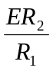 B 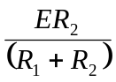 C 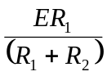 D 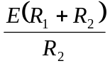

37 The figure below shows a potentiometer circuit. The balance length is AX.
E₀
A
X
B
P

When a 200 Ω resistor is inserted at P in series with the galvanometer,
A the balance length increases and the sensitivity of the galvanometer decreases
B the balance length decreases and the sensitivity of the galvanometer decreases
C the balance length remains the same and the sensitivity of the galvanometer
decreases
D the balance length remains the same and the sensitivity of the galvanometer
increases

38 A β-particle is emitted by the decay of an unstable nucleus. β-particle is
A a proton B a neutron C an electron D a helium nucleus

39 Two α-particles with equal energies are fired towards the nucleus of a gold atom.
Which diagram best represents their paths?

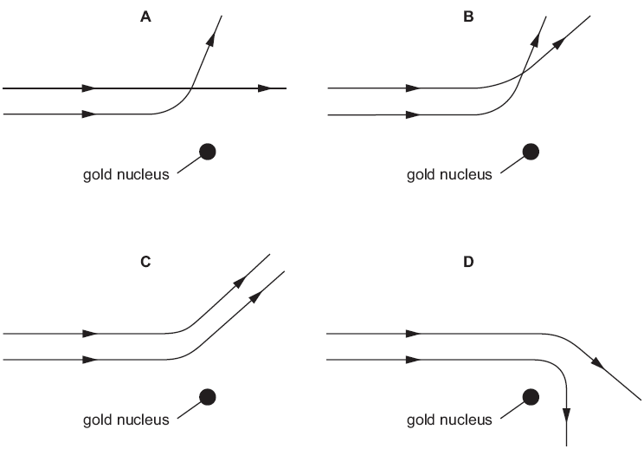

40 Which of the following quantities is conserved in a nuclear reaction?
A number of neutrons
B number of protons
C mass
D charge

